Linux Fundamentals

================================================================

Submitted to Vikul_Sir

Submitted by Nalathati Rahul

Submission Date –

L2 - As a Linux root user Create Files/Directory in the same Instance and change the ownership to a new user

Step: 1 Step:1 Go to AWS console and login with credentials

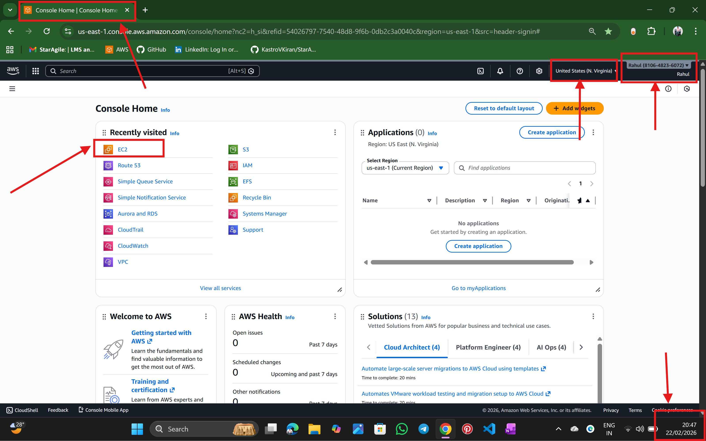

Step:2 Go to EC2 service

🡪select the name of the server

🡪select the AMI (Ubuntu)

🡪select the instance type

🡪select the key pair

🡪select the security group

And create instance by launch instance

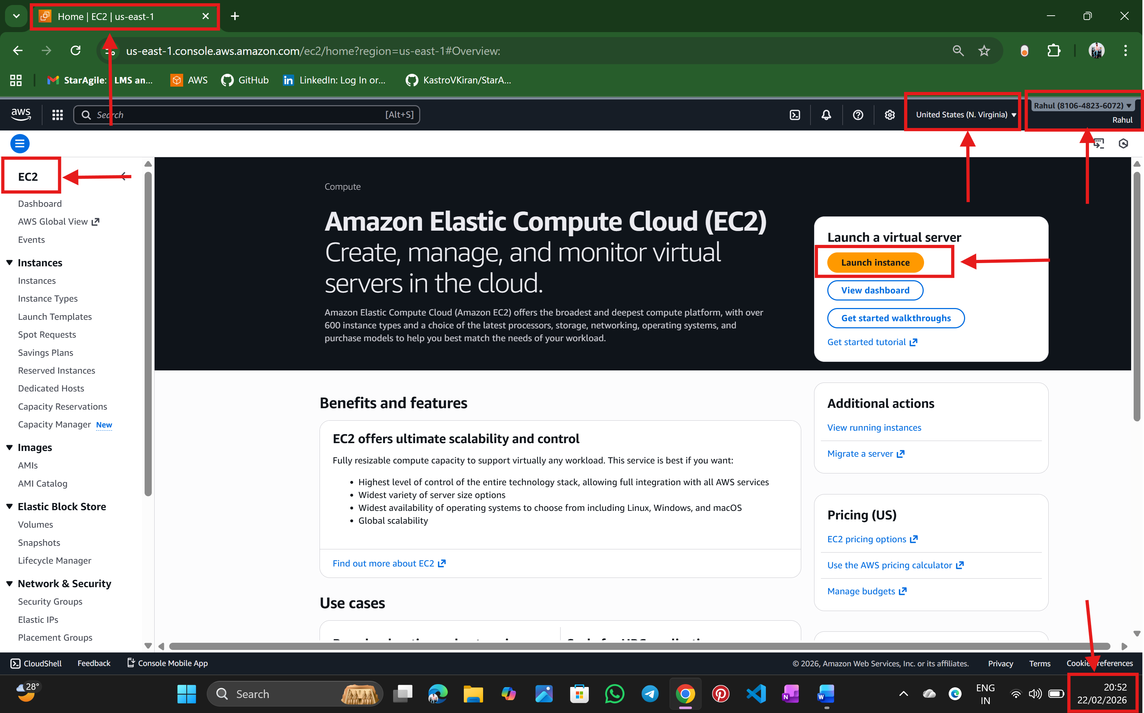

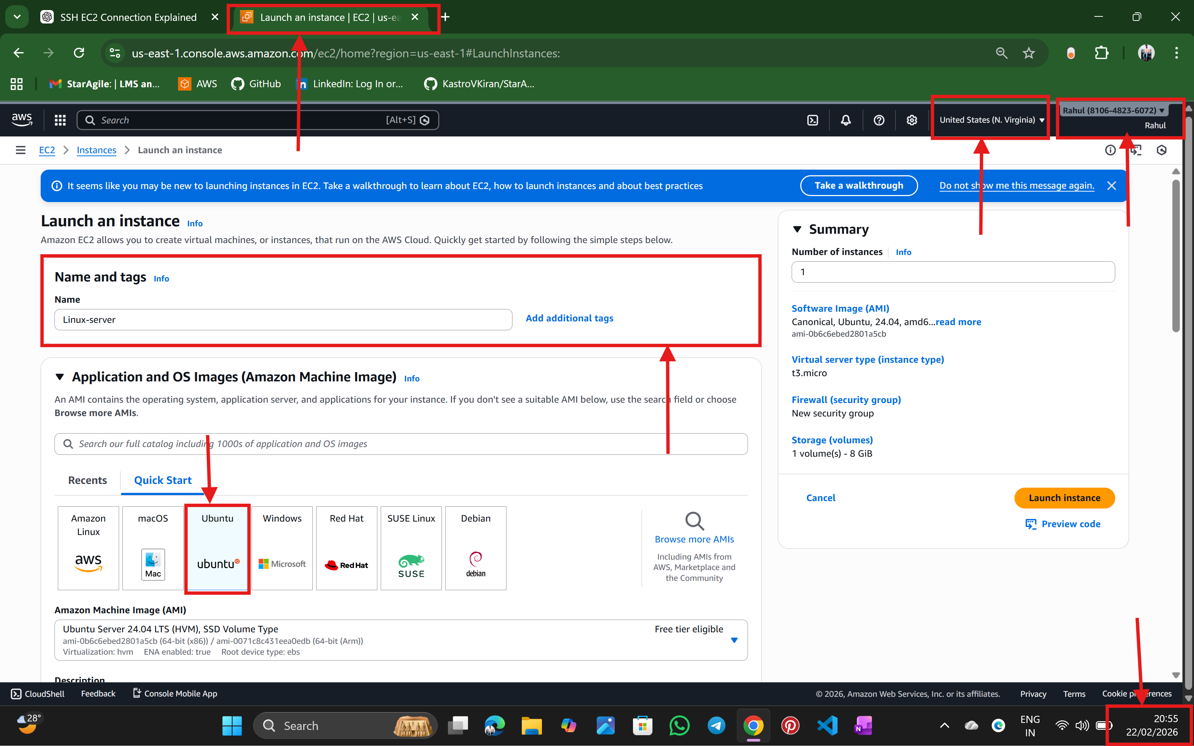

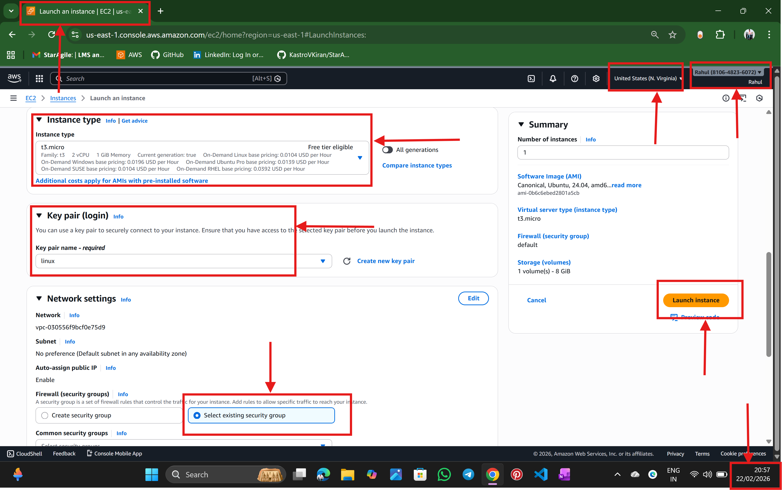

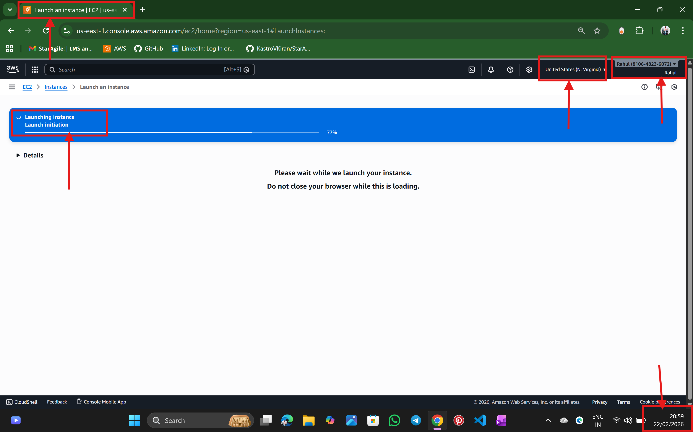

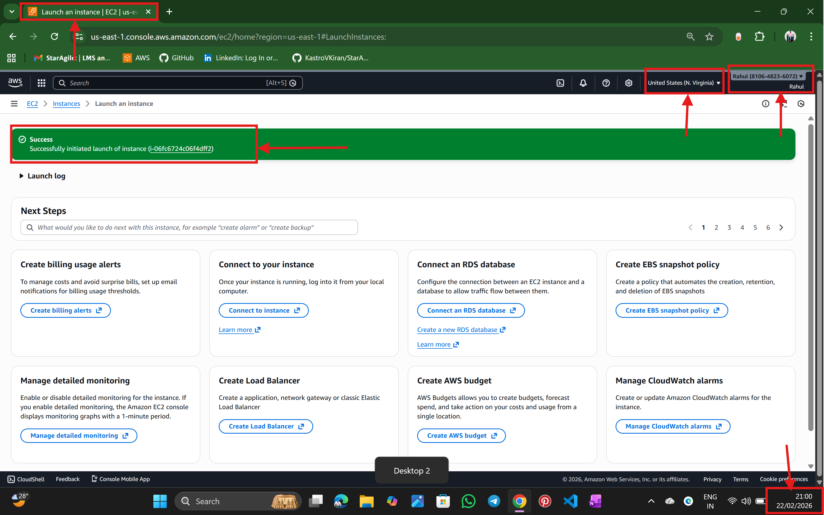

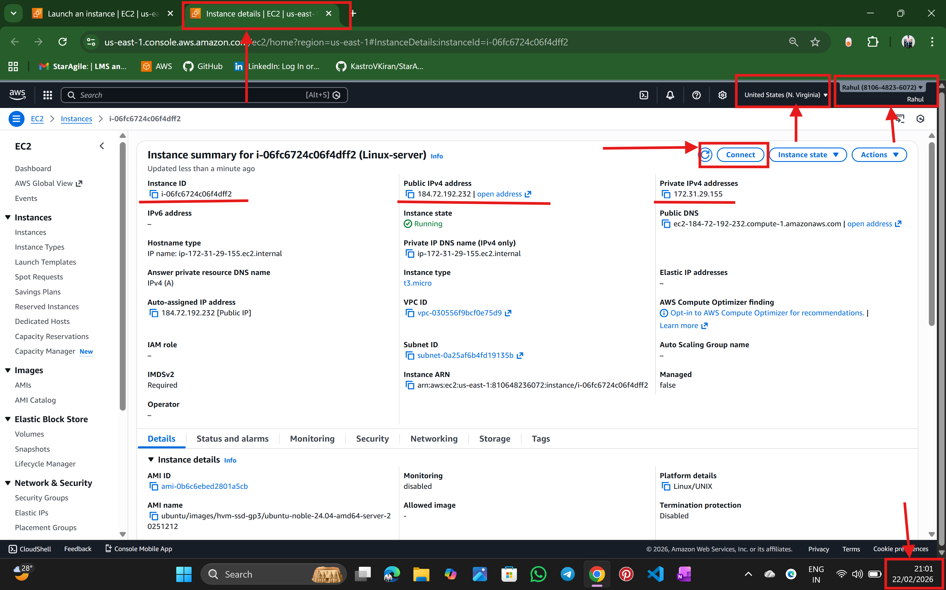

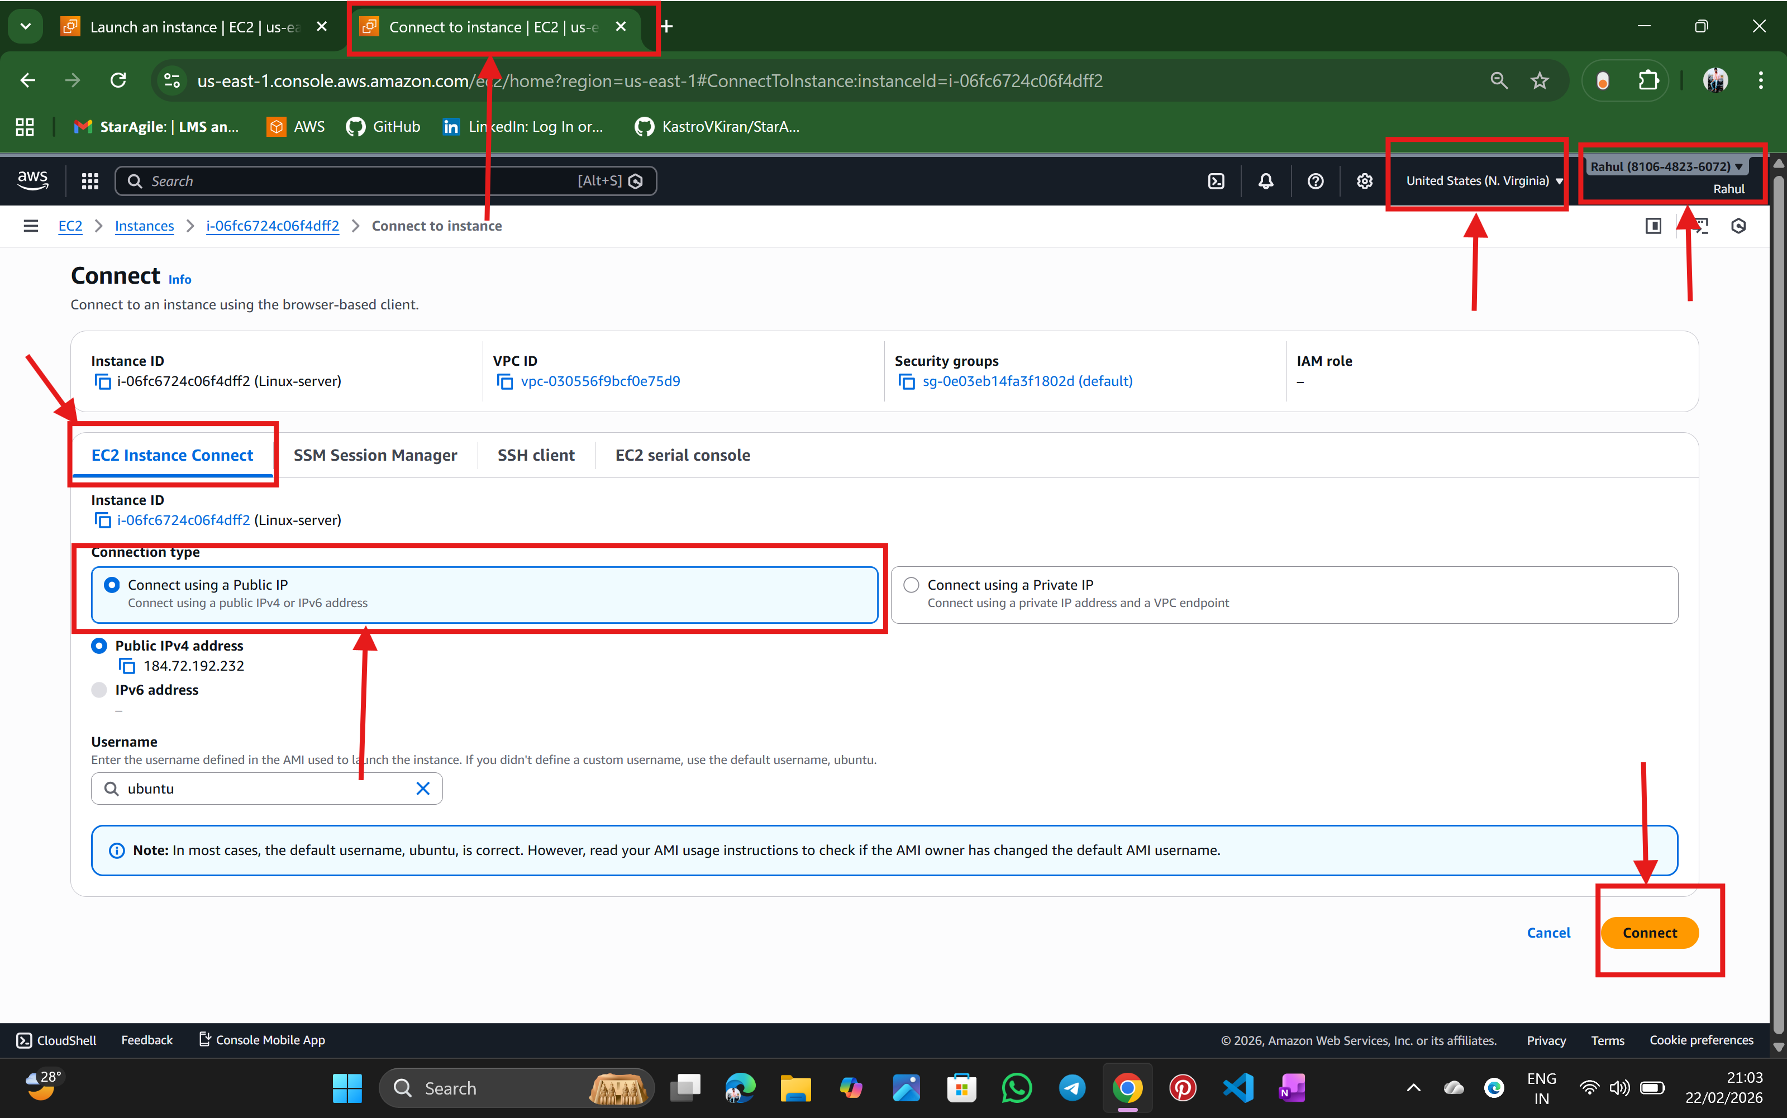

Step: 3 Now the Ubuntu terminal is opened

🡪Create a user: dev

🡪command to change ownership to user is 🡪 chown -R user folder /file

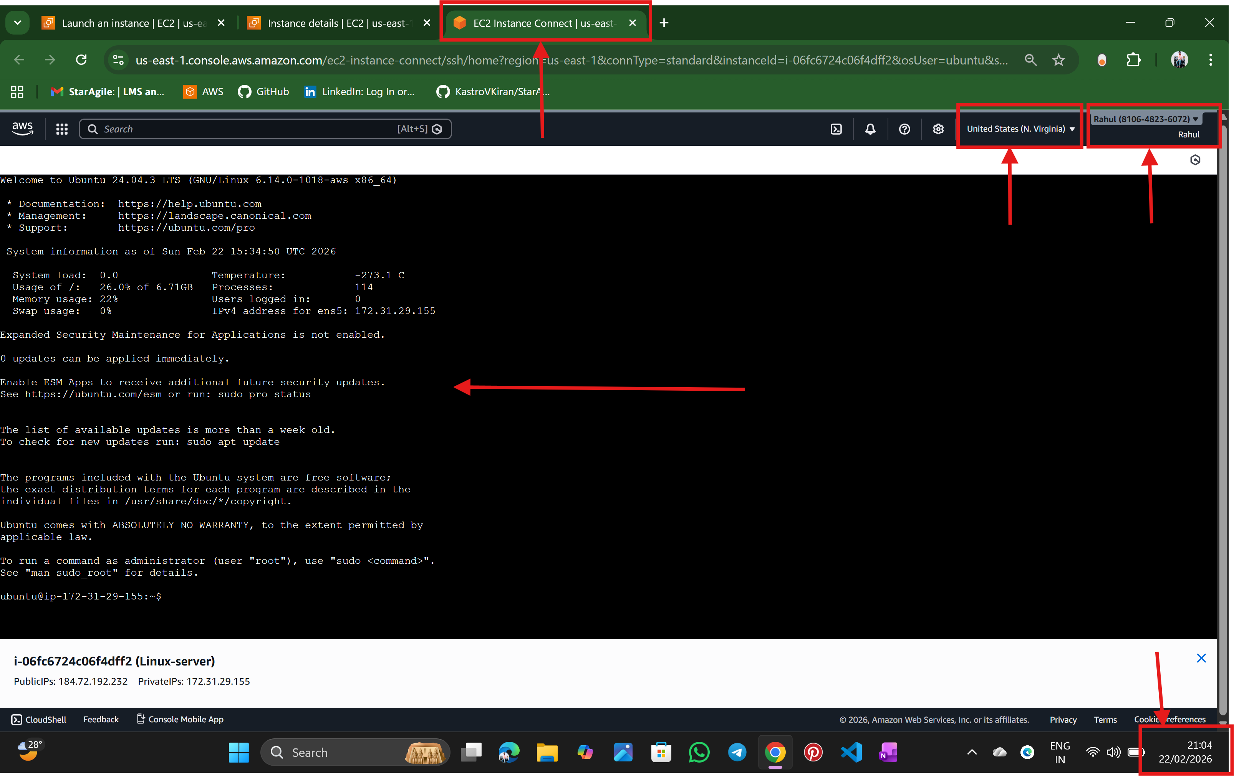

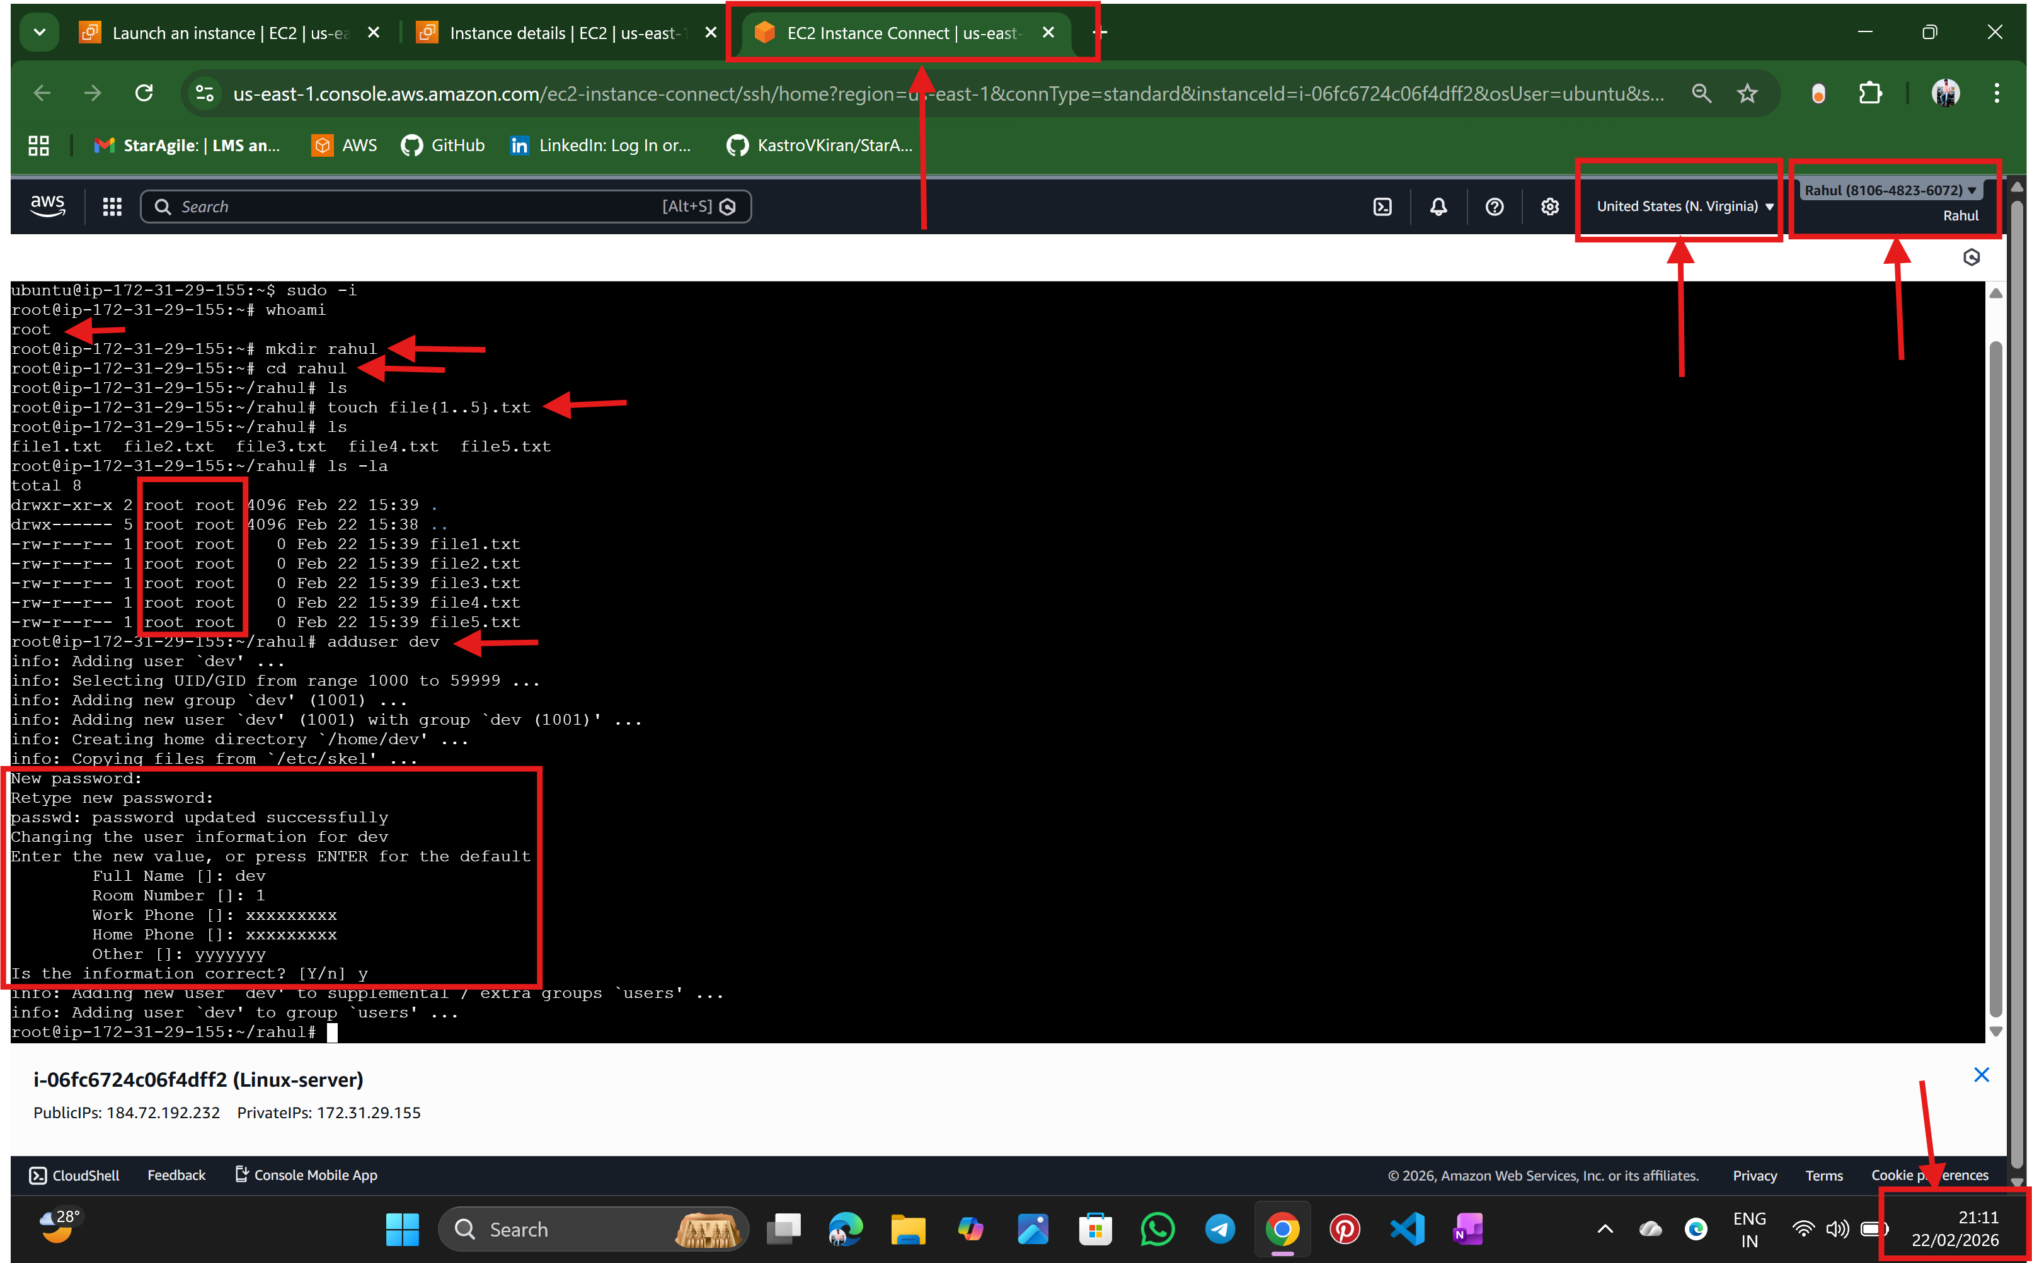

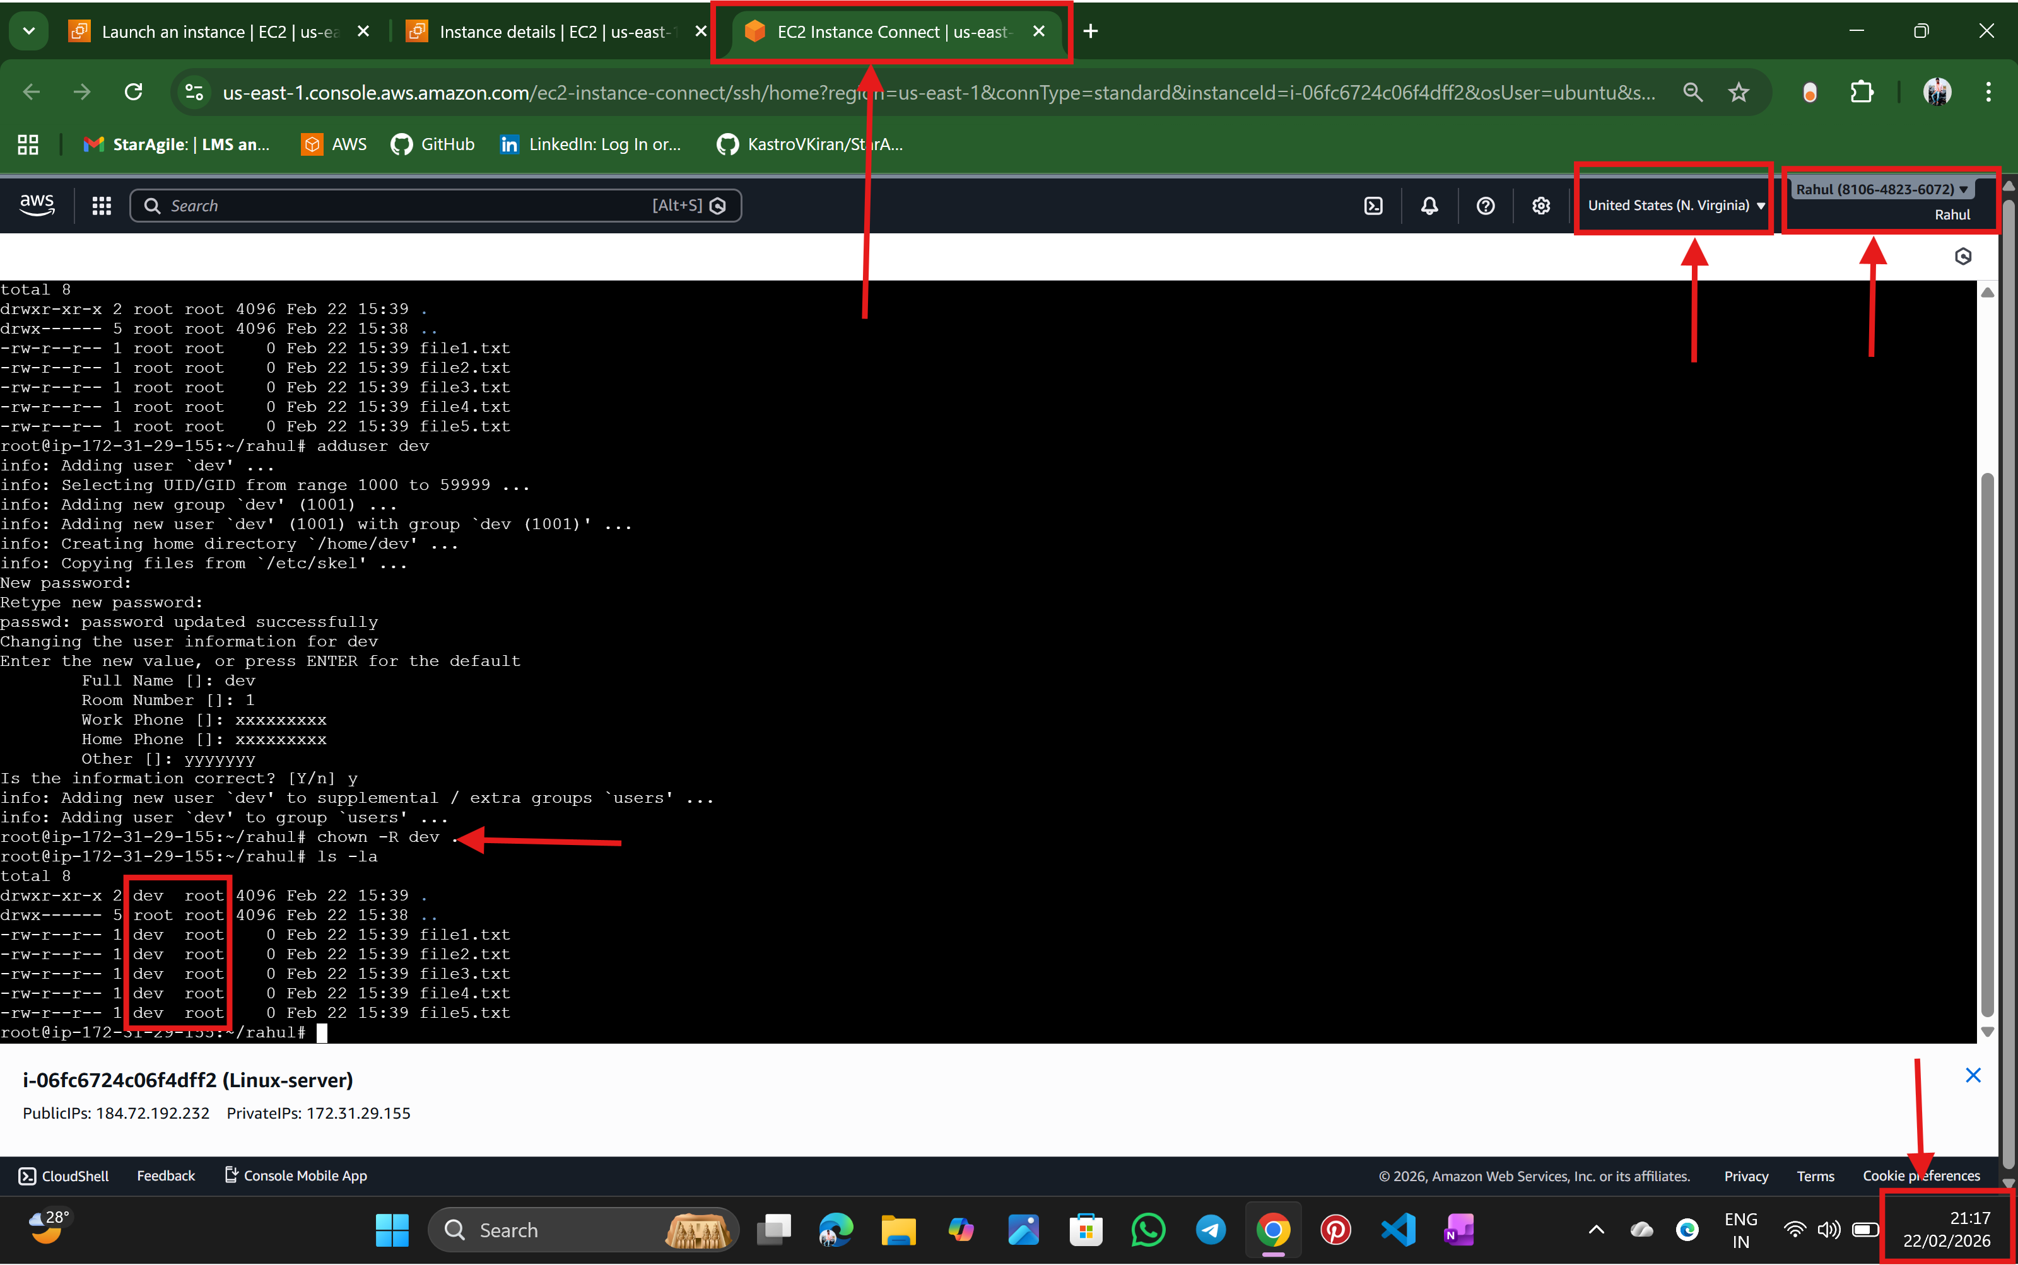

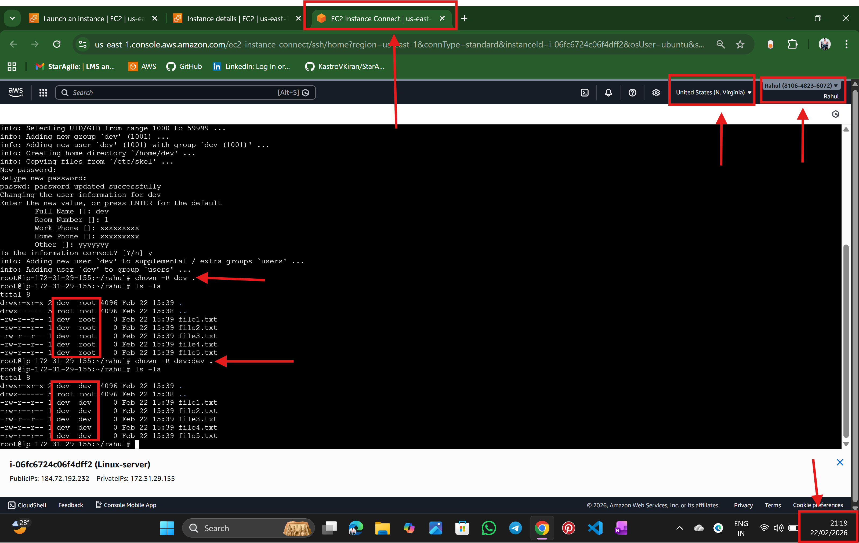

----------------------------------------------------------THE END----------------------------------------------------------------

🡪NALATHATI RAHUL